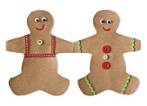
Grocery Bag
Gingerbread Folk

Craft Materials:

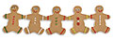
- Brown paper bag
- Scissors
- Gingerbread cookie cutter
- Pencil
- Markers
- Googly eyes
- Buttons
- Ribbons

Time needed: About 1 hour

Instructions:

- Cut a strip of paper from a brown bag. Measure the width of a gingerbread cookie cutter, then accordion-fold the bag to match the width of the cookie cutter. Trace the cutter onto the paper, making sure that each of the hands ends on a fold.
2. Use paper clips to secure the folded bag, then cut along the lines (be careful not to cut through the folds). Unfold the garland and decorate your "family" with markers, googly eyes, buttons, and ribbons. If you like, each folk with a name.

*This idea was found at Familyfun.com

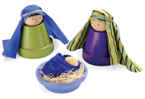
Terra-cotta
Trio

Craft Materials:
- 2 small terra-cotta pots
- 1 small terra-cotta saucer
- Acrylic paint
- Fine-point marker
- 3 wooden knobs, one smaller than the others
- Tacky glue
- Fabric
- Embroidery floss
- Raffia

Time Needed: About 1 hour

Instructions:

1. Paint the terra-cotta pots and saucer. Use a fine-point marker to draw faces on the wooden knobs.
2. Once the paint is dry, turn the pots upside down and use tacky glue to attach a larger head to the bottom of each pot. When the glue is dry, drape a piece of fabric around the top of each head and tie it in place with embroidery floss.
3. Form a swaddling blanket from another piece of cloth, as shown, gluing it to secure the shape. Glue the small head to the blanket and set it in the saucer on a bed of raffia.

